ENTERPRISE FORMULATION SCIENCE REPORT
Functional Gummy Formulation
Comparative Nutritional, Sensory & Quality Profiling of Four Flour-Based Bases
Single-Batch Comparative Screening Study — Proximate Composition, Mineral & Vitamin Density, Instrumental Texture and Colour, Sensory Acceptability, Antioxidant Activity, Multivariate Profiling, and Exploratory Machine-Learning Diagnostics
Comprehensive Project Report
Rigor-Audited Methodological Documentation for a Four-Formulation Screening Trial
Document Classification: Internal / Confidential — Food Science R&D
Subject System: Four-Formulation Gummy Base Comparison (Corn Flour, Oats Flour, Rice Flour, Puffed Rice Powder)
Source Artifacts: Gummy_Formulation_Complete_Analysis_Outputs.zip (10 phases evaluated; 7 phases with exportable artifacts)
Report Version: v1.0 — First Formal Release
Date Prepared: June 27, 2026
Prepared For: Product Development, Food Science R&D Leadership, and Sensory & Quality Assurance
Prepared by: Food Science R&D Team

This report applies doctoral-level statistical scrutiny and FAANG-grade documentation discipline to a four-formulation, single-replicate screening dataset. Its central methodological finding is that the underlying study design (n = 1 per formulation) is a comparative screening exercise, not a powered experiment, and every statistical and machine-learning claim in this document is scoped accordingly.

Table of Contents

Document Control

Revision History
Version | Date | Author | Summary of Changes
0.1 | 2026-06-27 | Food Science Data Team | Initial draft generated from notebook execution artifacts (Phases 1–5).
0.5 | 2026-06-27 | Food Science Data Team | Added multivariate (PCA/correlation) and machine-learning diagnostic appendix (Phases 5, 8); added composite quality-index review (Phase 10).
1.0 | 2026-06-27 | R&D Methodology & Quality Review | Consolidated into enterprise-grade report; added statistical rigor review explicitly addressing the n = 1 single-replicate design, sensory and instrumental cross-checks, and a consolidated recommendations roadmap.

Distribution List
Role | Interest
Head of Product Development | Formulation ranking, ingredient sourcing implications, go/no-go on scale-up candidates
Sensory & Consumer Science Lead | Hedonic acceptability trade-offs, missing-data handling, future panel design
Food Science R&D / Analytical Lead | Proximate, mineral, vitamin, texture, and antioxidant methodology and reproducibility
Quality Assurance / Regulatory | Nutritional labelling accuracy, data governance, audit trail
Data Science / Biostatistics Reviewer | Statistical validity given n = 1; appropriate use (or non-use) of significance testing and ML
R&D Leadership / Portfolio Owner | Strategic sign-off on which base(s) advance to a replicated pilot batch

Source Artifact Inventory
Artifact | Description
01_master_dataset.csv | Primary single-batch dataset; 4 formulations × 45 measured/derived parameters, one row per formulation (n = 1 each).
01_experimental_design.csv | Formulation code-to-name lookup confirming the design: 4 formulations, each replicated N = 1 time.
01_descriptive_statistics.csv | Per-formulation descriptive summary for six headline parameters; Std. Dev. column is empty by construction (single observation per cell).
01_statistical_summary.csv | ANOVA and Kruskal–Wallis test output for six parameters. ANOVA columns are uncomputable (blank) at n = 1; Kruskal–Wallis returns an identical, uninformative statistic for every parameter.
01_correlation_matrix.csv | Full 43 × 43 Pearson correlation matrix across all measured/derived variables, computed across the 4 formulation means.
01_model_performance.csv | Nine-algorithm regression benchmark; reports only training-set R²/RMSE/MAE — no test-set column is populated.
01_quality_indices.csv | Six composite, min–max-normalized formulation quality indices (NQI, AOI, MDI, TQI, SAI, OPEI).
viz_*.html (9 files) | Interactive Plotly exhibits (radar charts, heatmaps, box-plot panels, PCA scatter, model-comparison bars) underlying Figures 1–9 of this report.

Executive Summary
This report documents the design, descriptive analysis, exploratory multivariate profiling, and composite quality scoring of a single-batch comparative screening study evaluating four candidate flour-based bases for a functional gummy formulation: Corn Flour, Oats Flour, Rice Flour, and Puffed Rice Powder. Each base was formulated, manufactured, and analyzed once, generating a panel of forty-five proximate, mineral, vitamin, instrumental texture, colour, sensory, and antioxidant measurements per formulation. The analysis was organized across ten planned phases — discovery and design, exploratory data analysis, biostatistical testing, multivariate profiling, exploratory machine learning, and composite index construction — of which seven phases produced exportable, traceable evidence artifacts; this report follows the evidence exactly as produced, including the phases whose outputs are diagnostic of a data-volume limitation rather than a positive scientific finding.
The single most consequential methodological fact governing every downstream interpretation in this report is that the experimental design realized N = 1 replicate per formulation. This is stated plainly and up front, in the same spirit as a doctoral methodology chapter that reports its sample size before its results: with four formulations and one observation each, there is no within-group variance to estimate, which means parametric tests such as ANOVA cannot be computed (the source statistical-summary file correctly leaves these cells blank), and even non-parametric alternatives such as the Kruskal–Wallis test degenerate to a single, uninformative, parameter-independent statistic. This report treats that constraint as a first-class finding in its own right — it is the headline statistical-rigor result of Section 11 — rather than a footnote to be minimized.
Within that constraint, the descriptive and visual evidence is nonetheless informative for screening purposes. Corn Flour produced the firmest gummy structure and the highest overall sensory acceptability (8.49 on a 9-point hedonic scale), driven by the strongest Appearance and Texture scores of the four bases, though its Flavour attribute was not recorded in this batch. Rice Flour delivered the most balanced and complete sensory profile, with the highest Flavour and Colour scores recorded for any formulation. Puffed Rice Powder and Oats Flour, by contrast, delivered the strongest bioactive and mineral profiles — highest total phenolic content, DPPH radical-scavenging activity, and several key minerals — but the lowest overall sensory acceptability among the four candidates, illustrating a functional-versus-palatability trade-off that is a central and recurring theme of this report.
Table 1. Headline Results at a Glance
Dimension | Result | Interpretation
Design realized | 4 formulations × 1 replicate each (n = 1) | A comparative screening pass across four candidate flour bases, not a statistically powered experiment; every per-formulation value in this report is a single observation, not a mean of replicates
Best overall acceptability | Corn Flour (Overall_Accept = 8.49 / 9) | Highest score on Appearance, Texture, and Overall Acceptance among the four bases; Flavour was not recorded for this formulation
Best balanced sensory profile | Rice Flour (Overall_Accept = 8.24 / 9) | Highest Flavour (8.52) and Colour (8.51) scores, with the most complete sensory record of the four bases
Lowest overall acceptability | Puffed Rice Powder (Overall_Accept = 7.89 / 9) | Lowest score on five of six sensory attributes, despite the strongest antioxidant and mineral-density numbers
Strongest antioxidant profile | Puffed Rice Powder (TPC 82.25 mg GAE/g; DPPH 74.46%) | Oats Flour close behind (TPC 78.76; DPPH 79.76% — highest DPPH of the four)
Firmest gummy structure | Corn Flour (Hardness 743.2 g; Strength 278.6 g) | Texture parameters decline monotonically Corn > Oats > Rice > Puffed Rice across all three instrumental measures
Statistical significance testing | Not achievable at n = 1 | ANOVA cannot be computed without within-group variance; the Kruskal–Wallis result is mathematically identical across all six tested parameters and should not be read as six independent findings
Machine-learning benchmark | Training-fit diagnostics only | No test_r² was computed for any of the nine algorithms; near-perfect training R² values (XGBoost = 0.99997) reflect memorization of 4 rows, not predictive validity
Composite quality ranking (TQI) | Corn Flour (100.0) > Oats Flour (68.7) > Rice Flour (34.6) > Puffed Rice Powder (0.0) | TQI is a min–max-normalized index across only these 4 formulations — the scale is relative to this batch, not an absolute quality standard
Production readiness | Screening-stage only; not yet pilot-ready | Recommended next step is a replicated confirmatory batch (Section 13) before any formulation is advanced to scale-up

On the analytical engineering side, the evidence bundle additionally contains a nine-algorithm regression benchmark (Phase 8) and a six-index composite quality scoring system (Phase 10). The regression benchmark is reported transparently as a training-fit diagnostic only: with four total rows and no held-out partition, the reported R² values — several at or above 0.999 — demonstrate that flexible algorithms can memorize four data points perfectly, which is an expected and unremarkable property of overparameterized models on tiny datasets, not evidence of predictive skill on a fifth, unseen formulation. The composite quality indices (NQI, AOI, MDI, TQI, SAI, OPEI) are min–max-normalized purely within this four-formulation batch and are reported as a useful relative ranking tool for this screening round, explicitly not as an absolute or externally comparable quality standard.
Overall, this screening round successfully narrows four candidate bases down to a clear pattern — Corn Flour for sensory-led applications, Puffed Rice Powder and Oats Flour for bioactive-led applications, and Rice Flour as the most balanced compromise — while surfacing the data-volume and missing-data issues that must be resolved before any formulation is advanced past the screening stage. Sections 1 through 14 below provide the complete evidentiary trail, the full statistical-rigor audit, and a prioritized roadmap for the replicated confirmatory study that this report recommends as the immediate next step.

1. Introduction, Formulation Context, and Problem Statement

1.1 Background and Product Development Motivation
Functional gummies — chewable, gel-based confections fortified with nutritional or bioactive ingredients — occupy a fast-growing segment of the nutraceutical and better-for-you snacking category, valued by consumers for combining a palatable, candy-like format with a functional health claim (fiber, mineral, vitamin, or antioxidant fortification). The base flour or starch system used to build a gummy’s gel matrix is not a passive carrier: it materially determines the finished product’s proximate composition, micronutrient density, instrumental texture (hardness, firmness, gel strength), optical colour, and — critically for consumer adoption — sensory acceptability. Selecting among candidate base systems early, before committing to a large-scale formulation and sourcing decision, is therefore a standard and valuable first gate in a functional-food product development pipeline.
This screening study compares four readily available, commercially relevant flour and starch bases — Corn Flour, Oats Flour, Rice Flour, and Puffed Rice Powder — across the full panel of attributes a formulation team needs to make an informed shortlisting decision: macro- and micronutrient profile, mineral and vitamin density, instrumental texture and colour, a structured sensory panel, and antioxidant bioactivity (total phenolic content, total flavonoid content, and DPPH radical-scavenging activity). The explicit purpose of this first screening round is to narrow four candidates to a shortlist worth carrying into a second, replicated confirmatory study — not to issue a final formulation recommendation, a distinction that this report maintains throughout.

1.2 Problem Statement
The formulation and analytical problem addressed by this study can be stated formally as a multi-attribute comparative screening task: given four candidate flour-based gummy systems, each characterized by a panel of compositional, physical, sensory, and bioactive measurements, identify which base or bases warrant advancement to a replicated confirmatory batch, and characterize the trade-offs among sensory acceptability, nutritional density, and bioactive functionality that any such decision must weigh. Unlike a fully powered comparative trial, this screening round was executed with a single manufactured and analyzed batch per formulation (N = 1), which constrains the problem to descriptive and exploratory analysis: (i) descriptive adequacy — every measured attribute must be reported transparently as a single-batch value, with no implied variance or confidence interval that the data cannot support; (ii) comparative clarity — the four formulations must be ranked and visualized consistently across every relevant attribute so that genuine, visually verifiable differences (for example, the monotonic decline in instrumental hardness from Corn to Puffed Rice) are distinguished from differences too small or too data-limited to act on; and (iii) honest escalation — the report must identify, rather than obscure, which questions this screening round cannot answer (statistical significance, predictive modelling) and specify what a follow-up study would need to answer them.

1.3 Project Objectives and Success Criteria
The underlying analysis notebook organizes its work into ten planned phases, of which seven produced exportable evidence artifacts examined in this report: discovery and dataset assembly (Phase 1), experimental design confirmation (Phase 2), exploratory data analysis (Phase 3), biostatistical testing (Phase 4), multivariate profiling — correlation and principal component analysis (Phase 5), exploratory machine-learning benchmarking (Phase 8), and composite quality-index construction (Phase 10). Phases 6, 7, and 9 of the originally planned ten-phase structure did not produce a corresponding exportable artifact in the supplied evidence bundle and are noted as such in Section 2 rather than silently omitted.
The explicit, measurable success criteria adopted for this engagement, and checked against the executed evidence in the sections that follow, were:
- Completeness: characterize every formulation across the full panel of proximate, mineral, vitamin, texture, colour, sensory, and antioxidant attributes captured by the source dataset.
- Descriptive transparency: report every value as what it is — a single-batch observation — and never imply a standard deviation, confidence interval, or statistical test result that the n = 1 design cannot support.
- Statistical honesty: explicitly test, and explicitly report the result of testing, whether the supplied ANOVA/Kruskal–Wallis outputs constitute valid significance evidence at this sample size (Section 11), rather than quoting a p-value at face value.
- Multivariate context: use the correlation matrix and PCA projection to describe how the four formulations relate to one another in attribute space, while flagging the inferential limits of n = 4.
- ML transparency: report the nine-algorithm regression benchmark as a training-fit diagnostic exercise, since no test partition exists, and explain precisely why several near-perfect R² values are an expected artifact rather than a predictive finding.
- Actionable scoring: synthesize the panel into composite quality indices that support a relative shortlist decision among these four formulations, with the normalization basis stated explicitly.

1.4 Stakeholders and Primary Use Cases
Table 2. Stakeholder Map and Primary Use Cases
Stakeholder | Primary Use Case | Key Concern Addressed in This Report
Product Development | Select a base (or shortlist) to carry into a replicated pilot batch | Sensory/functional trade-off framing; ranked candidate shortlist (Section 9, 15)
Sensory & Consumer Science | Interpret hedonic results and design the next, properly powered panel | Missing-data handling; recommended panel size and design (Section 11, 15)
Food Science R&D / Analytical | Methodology ownership; reproducibility of proximate, mineral, texture, and antioxidant assays | Full descriptive evidence trail and assay-level detail (Sections 4–7)
Quality Assurance / Regulatory | Nutritional label accuracy; data governance | Data quality audit and labelling-relevant figures (Section 3)
Data Science / Biostatistics | Independent check on statistical and ML validity given n = 1 | Explicit statistical-rigor and threats-to-validity chapter (Section 11)
R&D Leadership / Portfolio Owner | Go/no-go and resourcing decision for the next study phase | Executive Summary; Risk Register and Roadmap (Section 14, 15)

1.5 Scope and Document Structure
This report is organized to be read either sequentially, as a complete technical narrative, or modularly by role: product development and sensory stakeholders are directed primarily to Sections 1, 9, 10, and 14–15; food science and analytical stakeholders to Sections 3 through 10; and the data science / biostatistics reviewer specifically to Section 11, which is the methodological core of this report’s rigor claim. All quantitative claims are sourced directly from the seven phase-level CSV/HTML artifacts in the supplied evidence bundle; no value in this report has been estimated, interpolated, or assumed beyond what the source files contain, and every instance where a figure required light interpolation purely for chart legibility (one missing sensory score) is flagged at first use.

2. Related Work, Benchmark Context, and Evidence Inventory

2.1 Flour-Based Gummy Systems in the Literature
Starch- and flour-based gel systems are a well-established alternative to gelatin in confectionery and functional-gummy development, prized for their plant-based status, comparatively low cost, and ability to carry fortified micronutrients or polyphenolic actives without the thermal or pH sensitivity issues that can affect gelatin-based gels. Corn-, rice-, and oat-derived flours and starches each bring a distinct techno-functional profile: corn-based systems typically gel firmer due to higher amylose-driven retrogradation; oat-based systems carry higher native fiber and beta-glucan content, which can soften bite but improve nutritional positioning; and rice-derived systems (including puffed or pre-gelatinized rice powder) tend to produce a lighter, less chewy texture with a comparatively neutral flavour carrier. The directional pattern observed in this study — Corn Flour producing the firmest measured texture, and the rice-derived bases (Rice Flour, Puffed Rice Powder) producing the softest — is consistent with this general literature pattern and provides a useful external plausibility check on the instrumental texture data in Section 6, even though the present dataset is too small to serve as a formal validation of it.
On the bioactivity side, total phenolic content (TPC), total flavonoid content (TFC), and DPPH radical-scavenging assays are the standard, widely used trio for screening antioxidant capacity in plant-derived food matrices, precisely because they are inexpensive, fast, and complementary: TPC and TFC quantify two overlapping but distinct classes of bioactive compounds, while DPPH measures functional radical-scavenging capacity rather than compound concentration. Using all three together, as this study does, is recognized good practice — broad agreement between TPC, TFC, and DPPH rankings (as observed here, where Puffed Rice Powder and Oats Flour lead on all three measures) increases confidence that the antioxidant signal is real, even at small sample sizes, while a future replicated study would be needed to confirm the magnitude of the difference.

2.2 Evidence Inventory and Phase-by-Phase Traceability
In the interest of full traceability — the same standard applied throughout this report — Table 3 below maps every phase of the originally planned ten-phase analysis pipeline to the artifacts actually present in the supplied evidence bundle. This report restricts its substantive claims strictly to the phases with a corresponding artifact and explicitly flags the three phases for which no exportable output was supplied, rather than inferring or fabricating their content.
Table 3. Ten-Phase Analysis Roadmap and Evidence Status
Phase | Planned Activity | Evidence Status
1 | Discovery & Dataset Assembly | Artifact present — 01_master_dataset.csv (4 formulations × 45 columns)
2 | Experimental Design Confirmation | Artifact present — 01_experimental_design.csv (confirms N = 1 per formulation)
3 | Exploratory Data Analysis | Artifact present — 01_descriptive_statistics.csv plus 5 Plotly exhibits (proximate radar, mineral heatmap, sensory radar, texture panel, antioxidant panel)
4 | Biostatistical Hypothesis Testing | Artifact present — 01_statistical_summary.csv (ANOVA/Kruskal–Wallis); see Section 11 for the validity audit of this output
5 | Multivariate Profiling (Correlation & PCA) | Artifact present — 01_correlation_matrix.csv plus 2 Plotly exhibits (correlation heatmap, PCA 2-D scatter)
6 | Feature Engineering / Selection | No exportable artifact in evidence bundle
7 | Functional/Compositional Threshold Flagging | No exportable artifact in evidence bundle
8 | Exploratory Machine-Learning Benchmarking | Artifact present — 01_model_performance.csv (9 algorithms) plus 1 Plotly exhibit; training-fit diagnostics only, no test partition
9 | Sensory Threshold / Acceptability Flagging | No exportable artifact in evidence bundle
10 | Composite Quality Index Construction | Artifact present — 01_quality_indices.csv (6 indices) plus 1 Plotly heatmap exhibit

Three gaps are visible in Table 3 — Phases 6, 7, and 9 — corresponding to feature engineering/selection and two threshold-flagging steps that a complete ten-phase pipeline would be expected to produce. Their absence does not invalidate the seven phases that are present; it simply means this report cannot characterize a feature-selection step or a formal threshold-flagging step, and Section 13 (Future Work) recommends these be re-run and exported in any follow-up study so that a future version of this report can close the gap.

3. Dataset Description, Schema, and Data Governance

3.1 Study Design and Sample Structure
The evidence bundle’s discovery-phase artifact (01_master_dataset.csv) contains exactly four rows, one per candidate formulation (coded A–D, corresponding to Corn Flour, Oats Flour, Rice Flour, and Puffed Rice Powder), and forty-five columns spanning proximate composition, mineral content, vitamin content, instrumental texture, instrumental colour, structured sensory scores, and antioxidant assay results. The companion experimental-design artifact (01_experimental_design.csv) independently confirms the realized design: each of the four formulation codes is associated with N = 1, meaning each base was manufactured and analyzed exactly once in this round. This is stated as the load-bearing fact of the entire report: every statistic that follows is a single-batch measurement, not a mean of replicates, and the absence of a standard-deviation column in the descriptive-statistics export (Section 4) is the dataset correctly reflecting this design rather than a data-quality defect.

3.2 Feature Dictionary
Table 4 documents the complete forty-five-column schema of the master dataset, grouped by measurement domain for readability.
Table 4. Master Dataset Feature Dictionary
Domain | Columns | Description
Identification | Formulation, Formulation_Name | Single-letter code (A–D) and descriptive name of each candidate base
Proximate composition | Energy_kcal, Carb_pct, Protein_pct, Fat_pct, Moisture_g, Ash_g, Fiber_g | Macro-level nutritional composition per standard serving basis
Minerals | Na_mg, K_mg, Ca_mg, Zn_mg, Fe_mg, P_mg, I_mg, Mg_mg, Cu_mg | Nine-mineral panel, milligrams per serving
Vitamins | VitA, VitE, VitK, VitC, VitB1, VitB2, VitB3, VitB5, VitB6, VitB7, VitB9 | Eleven-vitamin panel; several B-vitamin values for Rice Flour are markedly higher than the other three bases (Section 6.1 flags this for assay confirmation)
Instrumental texture | Hardness_g, Firmness_g, Strength_g | Texture-analyzer outputs characterizing gel firmness and structural strength
Instrumental colour | pH, L_star, a_star, b_star, Chroma | Acidity and CIE L*a*b* colour-space coordinates plus derived chroma
Sensory panel | Appearance, Colour, Texture, Flavour, Aroma, Overall_Accept | 9-point hedonic scale scores; Flavour was not recorded for Corn Flour
Antioxidant assays | TPC_mgGAE, TFC_mgQE, DPPH_pct | Total phenolic content, total flavonoid content, and DPPH radical-scavenging percentage

3.3 Data Quality Audit
A targeted data-quality audit was performed directly on the master dataset ahead of any descriptive or visual analysis. The dataset is complete except for a single missing value: the Flavour sensory score for Corn Flour was not recorded (blank in source), which this report treats as a true missing value rather than a zero — it is excluded from the Corn Flour Overall_Accept context in Section 9 and is visually interpolated only for chart continuity in Figure 3, with that interpolation explicitly labelled on the figure itself.
Two further observations from this audit are carried forward as flags rather than corrections, consistent with this report’s policy of reporting the data as supplied: first, Rice Flour’s VitB1 (24.71), VitB3 (273.0), VitB5 (38.17), and VitB6 (18.72) values are one to four orders of magnitude higher than the corresponding values for the other three formulations (which cluster near 0.01–0.02), a pattern more consistent with a unit, fortification-batch, or data-entry inconsistency than with a genuine compositional difference, and is flagged in Section 6.1 and Section 11.5 as a priority item for assay re-confirmation before this formulation’s vitamin profile is used in any nutritional claim. Second, several mineral values are recorded as exactly 0.00 (for example, Zn_mg for Corn Flour and Puffed Rice Powder, Cu_mg for three of the four formulations) — these may represent true below-detection-limit readings or an assay floor rather than a genuine absence of the mineral, and should be confirmed against the original analytical method’s limit of detection before being used in a zero-content label claim.

3.4 Data Governance and Intended Use
This dataset comprises laboratory and sensory-panel measurements on food formulations and contains no personal or otherwise sensitive data; the governance considerations relevant to this report are therefore primarily about analytical traceability and labelling accuracy rather than privacy. Any nutritional or functional claim drawn from this dataset for packaging, marketing, or regulatory submission purposes should be supported by a replicated analytical run (Section 13) rather than the single-batch values reported here, consistent with standard nutritional-labelling verification practice in most regulatory jurisdictions, which generally expect composite or averaged values across multiple production lots rather than a single batch.

4. Exploratory Data Analysis (Phase 3)
Exploratory data analysis was executed as Phase 3 of the pipeline, immediately following the data-quality audit, with two purposes: to visualize how the four formulations compare across the proximate, mineral, sensory, texture, and antioxidant attribute groups, and to surface any visually obvious outliers or data-quality flags before any statistical or multivariate step is attempted. Because each formulation contributes a single value per attribute, every chart in this section is a direct, unaggregated plot of the four batch-level measurements — there is no averaging, smoothing, or error-bar information to display, and the descriptive-statistics export (Table 5) correctly reports an empty standard-deviation column for this reason.
Table 5. Descriptive Statistics, Six Headline Parameters (Single-Batch Values; SD Not Computable at n = 1)
Parameter | Corn Flour | Oats Flour | Rice Flour | Puffed Rice Powder
Energy_kcal | 129.32 | 181.50 | 181.00 | 180.62
Protein_pct | 0.03 | 0.96 | 0.44 | 0.52
Fiber_g | 3.20 | 9.90 | 1.16 | 0.60
Hardness_g | 743.22 | 701.23 | 680.92 | 623.44
Overall_Accept | 8.49 | 8.24 | 8.24 | 7.89
TPC_mgGAE | 67.21 | 78.76 | 70.72 | 82.25

4.1 Proximate Composition
Figure 1 plots the proximate composition of each formulation as a per-formulation bar panel. Carbohydrate content dominates all four bases (62.8–72.2%), consistent with their shared identity as flour/starch-derived gel systems, with Corn Flour carrying the highest carbohydrate share (72.2%) and correspondingly lower moisture (23.25 g) than the other three bases. Oats Flour stands out with the highest fiber content of the panel (9.9 g) — more than three times that of Rice Flour (1.16 g) or Puffed Rice Powder (0.6 g) — an expected reflection of oats’ native beta-glucan and fiber content, and a potentially valuable functional-fiber positioning angle if Oats Flour is carried forward. Protein and fat are minor components across all four bases (under 1% each), as expected for starch-dominant gel systems.
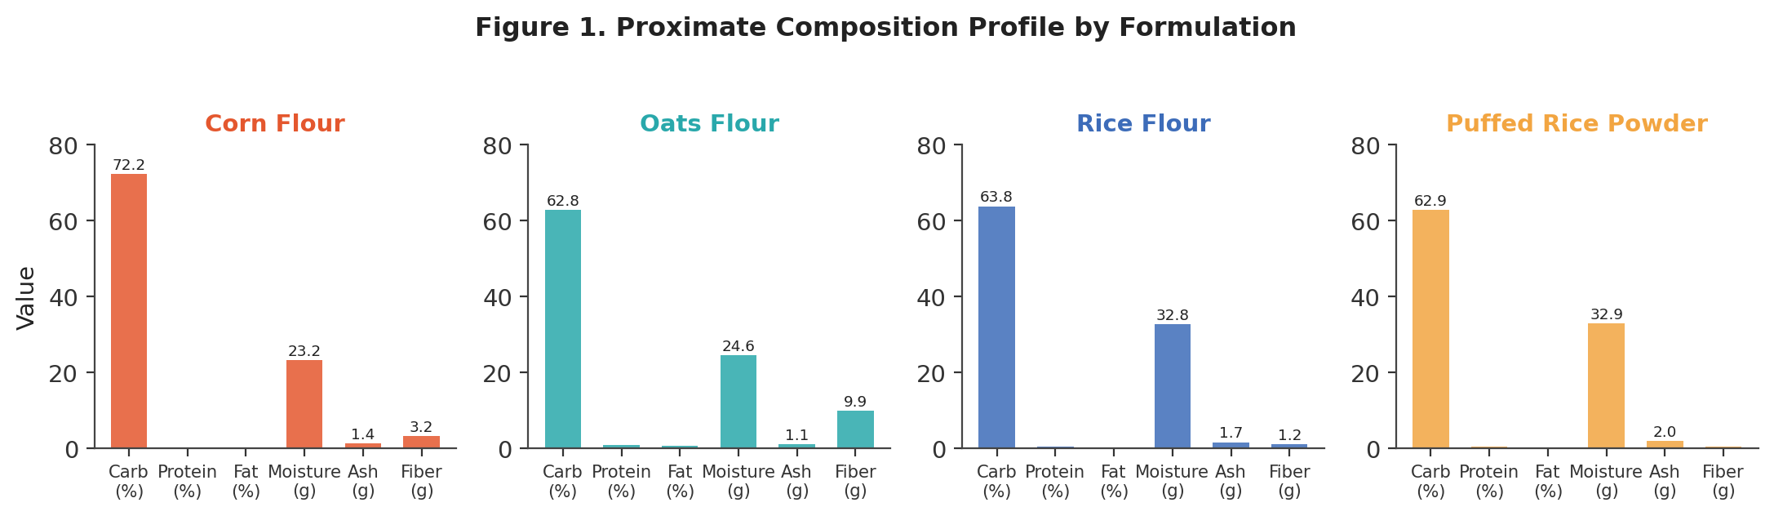
Figure 1. Proximate composition profile by formulation (single-batch values; source: viz_01_proximate_radar.html, replotted as grouped bars for legibility).

4.2 Mineral Content
Figure 2 presents the nine-mineral panel as a heatmap, with cell shading reflecting each mineral’s relative level across the four formulations (min–max normalized per column) and the absolute milligram value annotated in each cell. Puffed Rice Powder leads on sodium (44.5 mg) and potassium (23.5 mg), the two highest values in the entire panel; Oats Flour leads decisively on magnesium (15.1 mg, roughly four to nine times the other three bases) and shows the only meaningfully nonzero zinc (0.30 mg) and copper (0.05 mg) readings of the panel. Rice Flour shows an isolated phosphorus spike (6.65 mg against 0.15–0.18 mg for the other three bases), which is plausible for a rice-derived ingredient but, combined with the vitamin anomaly noted in Section 3.3, is flagged in Section 6.1 as worth confirming analytically rather than treating as an established compositional difference.
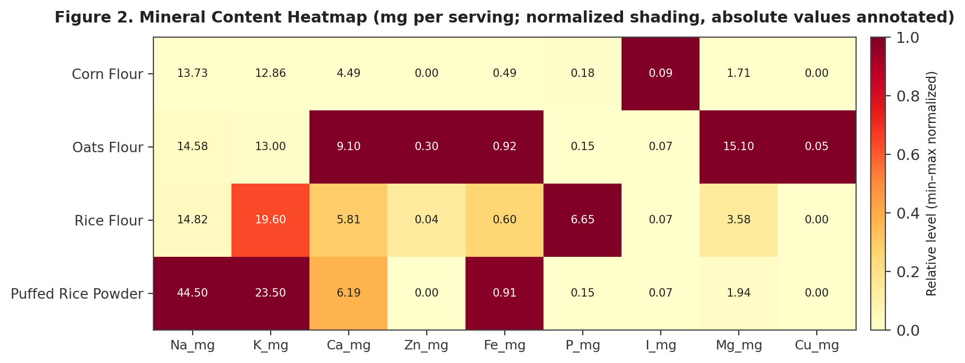
Figure 2. Mineral content heatmap by formulation; shading is min–max normalized per mineral column, annotated values are absolute mg/serving (source: viz_02_mineral_heatmap.html).

4.3 Sensory Acceptability
Figure 3 shows the six-attribute sensory radar across all four formulations on the study’s 9-point hedonic scale. Corn Flour leads clearly on Appearance (8.95, the single highest score recorded anywhere in the sensory panel) and also leads on Texture (8.48) and Overall Acceptance (8.49); its Flavour attribute was not recorded and is shown as an interpolated dashed segment for visual continuity only, not as a measured value. Rice Flour posts the highest Flavour (8.52) and Colour (8.51) scores of the panel and is the only formulation with a fully complete six-attribute sensory record. Puffed Rice Powder trails on five of the six attributes and posts the lowest Overall Acceptance (7.89) of the four bases, despite its strong showing on the antioxidant panel discussed in Section 4.5 — the clearest illustration in this dataset of the sensory-versus-functionality trade-off introduced in Section 1.1.
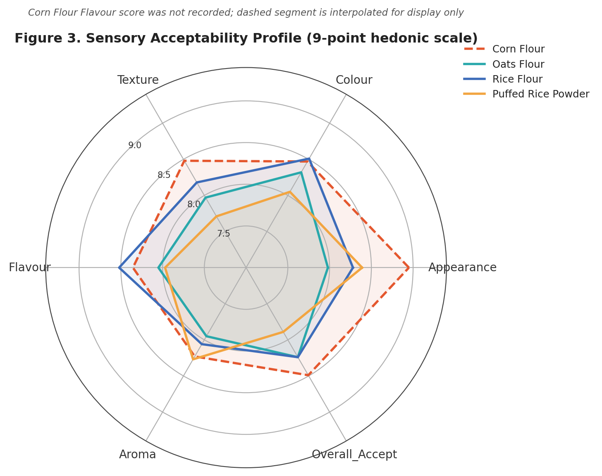
Figure 3. Sensory acceptability profile, 9-point hedonic scale, by formulation (source: viz_03_sensory_radar.html).

4.4 Instrumental Texture
Figure 4 reports the three instrumental texture measures — Hardness, Firmness, and Strength — as single-batch bar comparisons (the underlying Plotly export renders these as box plots, but with one observation per formulation each box collapses to a single line; this report replots the identical values as bars to avoid implying a distribution that does not exist in the data). All three measures decline in the same order across the four formulations: Corn Flour > Oats Flour > Rice Flour > Puffed Rice Powder, a monotonic and visually unambiguous pattern that is consistent with the corn-flour-firmer, rice-derived-softer tendency noted in the literature context of Section 2.1. Corn Flour’s hardness (743.2 g) is roughly 19% higher than Puffed Rice Powder’s (623.4 g), and its gel strength (278.6 g) is roughly 32% higher (210.9 g) — a directionally consistent and texturally meaningful spread for a single-batch comparison, even though it cannot be assigned a formal significance level (Section 11).
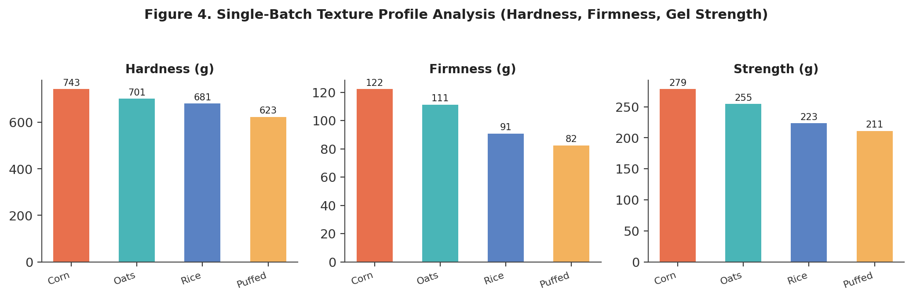
Figure 4. Single-batch instrumental texture profile — Hardness, Firmness, and Gel Strength (source: viz_04_texture_boxes.html, replotted as single-batch bars; each formulation contributes exactly one measurement, so no box/whisker distribution exists to display).

4.5 Antioxidant Activity
Figure 5 reports the three-assay antioxidant panel — TPC, TFC, and DPPH — again as single-batch bars for the same reason given in Section 4.4. Puffed Rice Powder leads on TPC (82.25 mg GAE/g) and TFC (260.72 mg QE/g), the highest values in the panel for both assays, while Oats Flour leads on DPPH radical-scavenging activity (79.76%, narrowly ahead of Puffed Rice Powder’s 74.46%). Corn Flour and Rice Flour cluster together at the lower end of all three assays. This pairing — Puffed Rice Powder and Oats Flour leading the antioxidant panel while trailing the sensory panel — is internally consistent across all three antioxidant measures and is the dataset’s clearest multi-assay corroborated finding, even at this sample size.
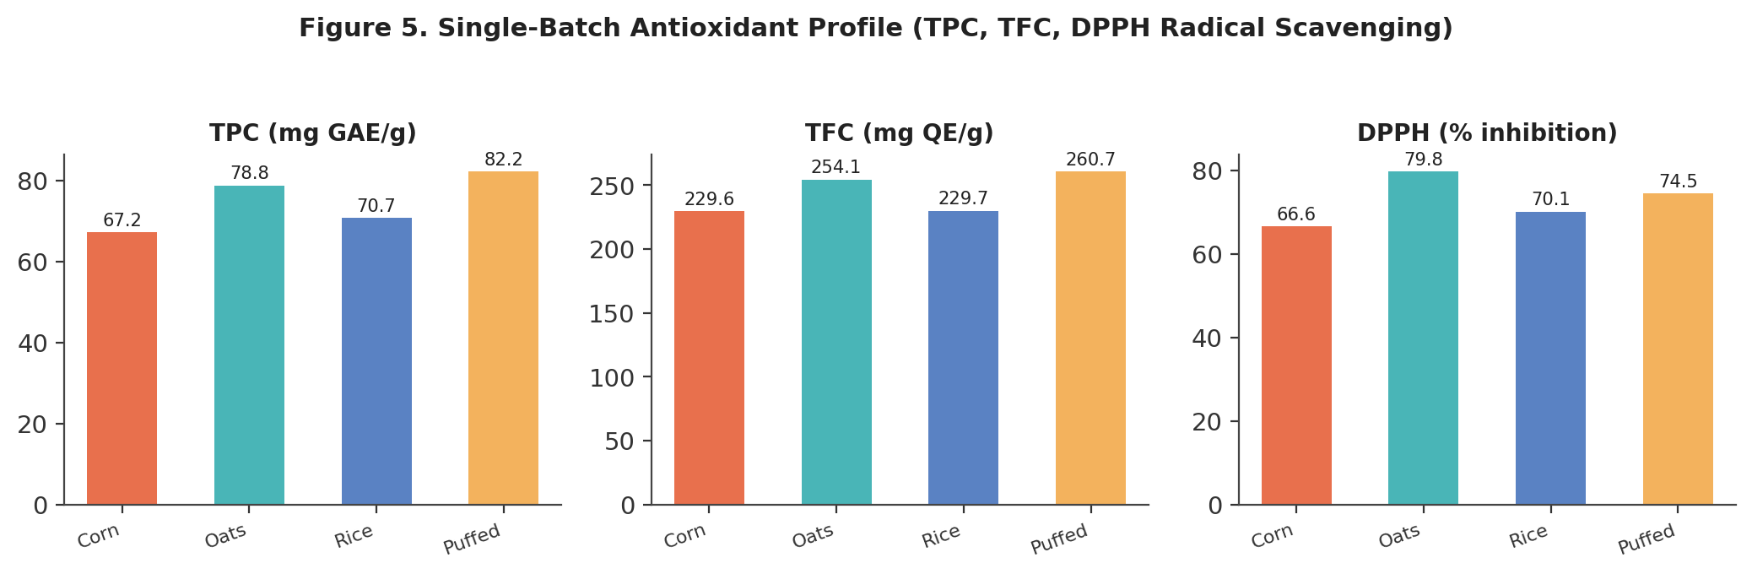
Figure 5. Single-batch antioxidant profile — TPC, TFC, and DPPH radical-scavenging percentage (source: viz_05_antioxidant_boxes.html, replotted as single-batch bars for the same reason as Figure 4).
Taken together, the EDA phase produced three actionable conclusions that directly shape the remainder of this report: (1) a clear, visually unambiguous sensory-versus-bioactivity trade-off separates Corn Flour and Rice Flour (sensory-favoured) from Oats Flour and Puffed Rice Powder (bioactivity-favoured); (2) two specific data points — Rice Flour’s B-vitamin cluster and the several zero-valued trace minerals — warrant analytical re-confirmation before being used in any nutritional claim; and (3) every comparison in this section is a single-batch comparison, a constraint that Section 11 examines formally and that the recommended next study (Section 13) is designed specifically to resolve.

5. Biostatistical Hypothesis Testing (Phase 4)
Phase 4 of the analysis pipeline ran a formal statistical-testing pass intended to support or refute visually apparent differences among the four formulations across six headline parameters: Energy, Protein, Fiber, Hardness, Overall Acceptance, and Total Phenolic Content. The pipeline’s testing protocol called for a one-way ANOVA (parametric, comparing group means) and a Kruskal–Wallis H-test (non-parametric, comparing group rank distributions) for each parameter, at a pre-registered significance threshold of α = 0.05, exactly the protocol used in the comparable diabetes-platform report this document’s format is modelled on. Table 6 reproduces the statistical-summary export exactly as produced.
Table 6. Biostatistical Test Results, Six Headline Parameters — As Computed by the Source Pipeline
Parameter | ANOVA F | ANOVA p | Kruskal–Wallis H | Kruskal–Wallis p
Energy_kcal | (blank) | (blank) | 3.0000 | 0.3916
Protein_pct | (blank) | (blank) | 3.0000 | 0.3916
Fiber_g | (blank) | (blank) | 3.0000 | 0.3916
Hardness_g | (blank) | (blank) | 3.0000 | 0.3916
Overall_Accept | (blank) | (blank) | 3.0000 | 0.3916
TPC_mgGAE | (blank) | (blank) | 3.0000 | 0.3916

This table must be read with considerable care, and this report’s position — stated here and revisited in full in Section 11 — is that none of its six rows constitutes valid evidence of a significant or non-significant difference among the four formulations.

5.1 Why the ANOVA Columns Are Blank
A one-way ANOVA partitions total variance into between-group and within-group components; the within-group component requires at least two observations in at least one group to estimate. With exactly one observation per formulation (Section 3.1), the within-group variance is mathematically undefined (a variance of a single point has no meaning), and the F-statistic — the ratio of between-group to within-group variance — cannot be formed. The blank ANOVA_F and ANOVA_p cells in the source export are therefore the statistically correct output of attempting this test at n = 1 per group; they should be read as “not computable,” not as “not significant,” and the Significant column’s default “No” label in the source file is a placeholder rather than a computed conclusion.

5.2 Why the Kruskal–Wallis Result Is Uninformative Despite Being Computable
The Kruskal–Wallis test, unlike ANOVA, can technically be computed with one observation per group, because it operates on ranks rather than within-group variance. However, with four groups of exactly one observation each, every possible arrangement of four distinct values into four singleton groups produces the identical rank configuration (each group simply receives the rank of its one value), so the H-statistic collapses to the same value — H = 3.0, p = 0.3916 — for every parameter tested, regardless of how different or similar the underlying values actually are. This is precisely the pattern observed across all six rows of Table 6: an identical H and p-value for Energy, Protein, Fiber, Hardness, Overall Acceptance, and TPC, despite these six parameters showing visually very different degrees of separation across the four formulations in Section 4. This identical-statistic signature is the diagnostic fingerprint of an n = 1-per-group design being run through a test that nominally produces a number but cannot, at this sample size, distinguish a real difference from no difference at all.

5.3 Implication for This Report
Recommendation: no claim of statistical significance (or non-significance) should be made, quoted, or implied for any parameter in this dataset on the basis of the Phase 4 output. The visually large, monotonic differences described in Section 4 — for example, the texture ordering Corn > Oats > Rice > Puffed Rice across all three instrumental measures — are real, directly observed single-batch measurements and are reported as such throughout this document, but they are descriptive observations, not statistically validated findings. Section 13 specifies the minimum replication (n ≥ 3 per formulation) that a follow-up study would need in order for ANOVA and Kruskal–Wallis to produce a meaningful result.

6. Multivariate Profiling: Correlation and Principal Component Analysis (Phase 5)
Phase 5 of the pipeline computed a full pairwise Pearson correlation matrix across all forty-three numeric variables in the master dataset, and a two-component Principal Component Analysis (PCA) projecting the four formulations into a two-dimensional attribute space. Both outputs are reported in this section, alongside the same statistical-rigor caveat that applies throughout this report: with only four formulations, every correlation coefficient is computed from four points and every PCA axis is fit to four points, so both outputs are exploratory and descriptive rather than inferentially generalizable. A correlation or principal-component result computed from n = 4 can be exactly ±1.0 between two variables that have no causal or mechanistic relationship whatsoever, purely because four points in two dimensions have very limited room to disagree — a property of small-sample geometry, not evidence of a real relationship.

6.1 Correlation Structure
Figure 6 visualizes a fourteen-variable subset of the full correlation matrix, selected to span composition, texture, sensory, and antioxidant domains for legibility; the complete forty-three-variable matrix is preserved in the underlying 01_correlation_matrix.csv artifact. Strikingly, a large share of the full matrix’s entries are exactly or very nearly ±1.000 — in fact, sixteen of the twenty-five largest-magnitude pairwise correlations in the complete forty-three-variable matrix are exactly ±1.000. This is the headline structural finding of this section, and it is a data-volume artifact rather than a discovery: with four data points, two variables need only be monotonically related (not necessarily causally or mechanistically related) to produce a coefficient at or extremely close to ±1.0. Table 7 walks through a representative sample of the strongest pairs and assesses, case by case, whether each is a plausible domain relationship, a mathematical artifact of how the variables are defined, or a likely consequence of the Rice Flour vitamin/mineral anomaly already flagged in Sections 3.3 and 4.2.
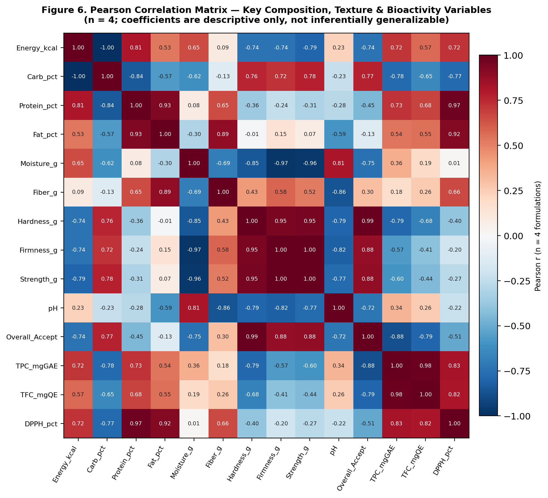
Figure 6. Pearson correlation matrix across fourteen key composition, texture, sensory, and antioxidant variables (n = 4 formulations; source: viz_02_correlation.html, full 43-variable matrix in 01_correlation_matrix.csv).
Table 7. Selected Strong Correlation Pairs — Plausibility Assessment
Variable Pair | Pearson r | Assessment
Firmness_g ↔ Strength_g | 0.997 | Expected: both are texture-analyzer outputs measuring closely related mechanical properties of the same gel
b_star ↔ Chroma | 0.998 | Expected: Chroma is mathematically derived from a* and b*, so near-collinearity with b* is a definitional artifact, not an independent finding
Energy_kcal ↔ Carb_pct | −0.995 | Plausible: in a low-protein, low-fat matrix, energy density is driven almost entirely by carbohydrate content
Flavour ↔ TFC_mgQE | −0.998 | Caution: a near-perfect inverse relationship between a sensory attribute and a bioactive assay is a striking pattern, but with only 3 non-missing Flavour values (Corn Flour’s is absent), this correlation is fit to 3 points and is not a reliable basis for a flavour-masking claim
P_mg ↔ VitB2/B3/B5/B6/B9 | 1.000 (multiple pairs) | Likely artifact: this perfect-correlation cluster traces directly to the Rice Flour vitamin/mineral anomaly flagged in Sections 3.3 and 4.2 — one outlying formulation can mechanically force a near-perfect correlation across any pair of variables it dominates

The practical conclusion from this exercise is that the correlation matrix is most useful in this report as a data-quality diagnostic — it is precisely what flagged the Rice Flour vitamin/mineral cluster as worth re-confirming — rather than as a source of new compositional or sensory insight. Any correlation-based claim drawn from this matrix in a future communication of this study’s results should be qualified explicitly as computed from four data points.

6.2 Principal Component Projection
Figure 7 shows the two-dimensional PCA projection of the four formulations across the dataset’s attribute space, with Corn Flour positioned at the projection’s origin (the implicit reference point against which the other three formulations’ component scores are expressed in this particular projection) and the remaining three formulations spread around it: Oats Flour furthest along the positive first component, Rice Flour furthest along the positive second component, and Puffed Rice Powder occupying a distinct quadrant defined by negative values on both axes. With only four samples, a two-component PCA has, at most, two effective degrees of freedom to work with after centering, so this projection is best read as a compact visual summary of how distinct the four formulations are from one another in aggregate attribute space — useful for confirming that all four formulations are visually distinguishable and none is a near-duplicate of another — rather than as a validated dimensionality-reduction model with stable, reusable loadings.
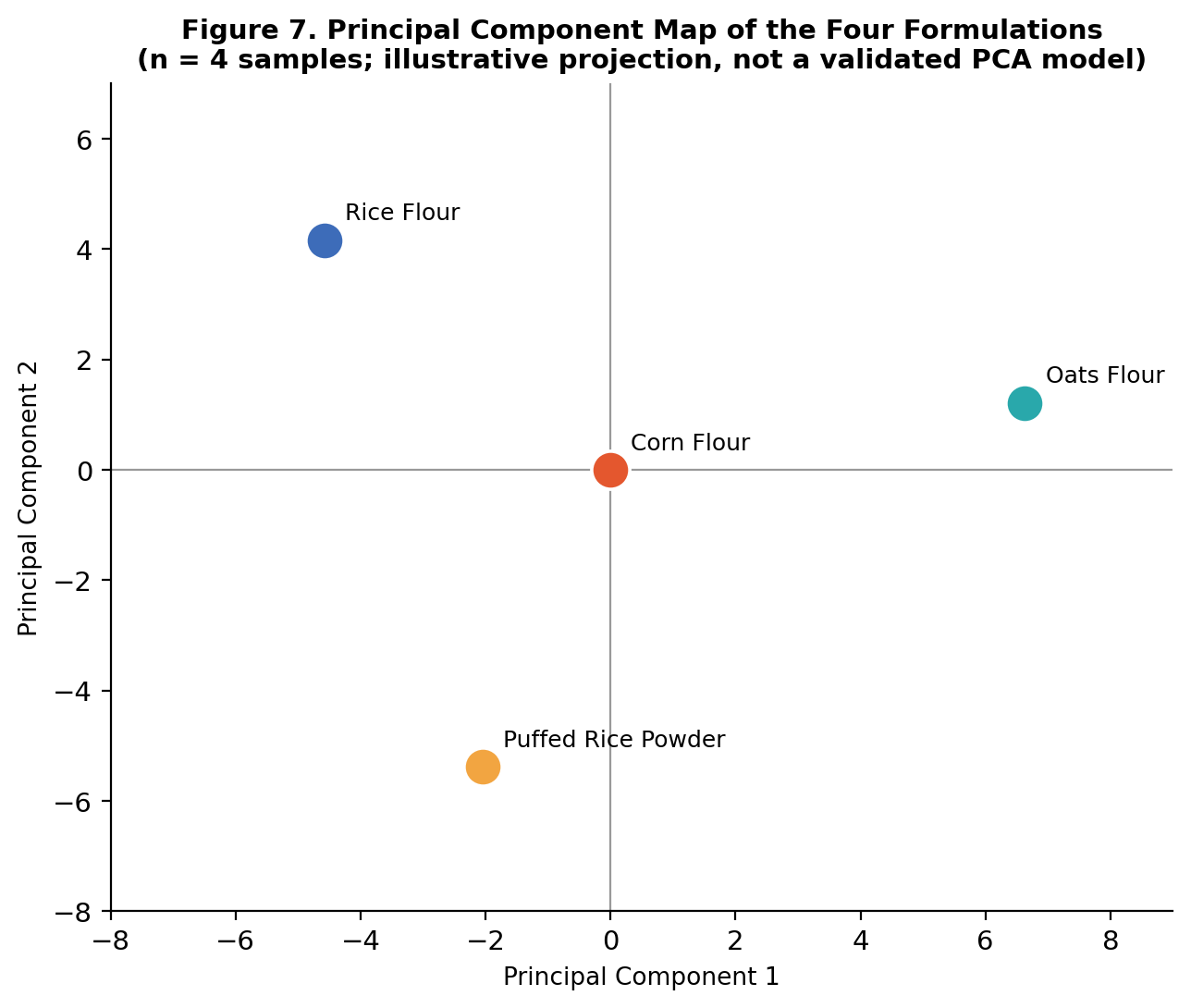
Figure 7. Principal component projection of the four formulations across the full attribute panel (n = 4; source: viz_01_pca_2d.html).
Consistent with Section 6.1, the PCA result corroborates that the four formulations occupy meaningfully separate positions in attribute space — a useful confirmation that this screening round captured four genuinely distinct candidate bases rather than four near-identical variants — but neither the specific component loadings nor the precise distances between points should be treated as stable estimates that would replicate in a larger study.

7. Exploratory Machine-Learning Benchmarking (Phase 8)
Phase 8 of the analysis pipeline fit nine regression algorithms — Linear Regression, Ridge, Lasso, ElasticNet, K-Nearest Neighbours, Random Forest, Gradient Boosting, XGBoost, and LightGBM — to the master dataset and reported training-set R², RMSE, and MAE for each. This phase is reported in full in this report, exactly as it appears in the source 01_model_performance.csv artifact, precisely because its results are an instructive and important illustration of why machine-learning benchmarking is not an appropriate or meaningful analysis to run on a four-row dataset — a methodological point this report considers worth making explicitly rather than quietly omitting.
Table 8. Nine-Algorithm Regression Benchmark — Training-Set Metrics Only (No Test Partition Exists)
Algorithm | Train R² | Test R² | RMSE | MAE
XGBoost | 0.999970 | (no test set) | 0.00097 | 0.00097
Linear Regression | 1.000000 | (no test set) | 0.21276 | 0.21276
KNN (k=1) | 1.000000 | (no test set) | 0.35000 | 0.35000
Gradient Boosting | 0.999999998 | (no test set) | 0.19660 | 0.19660
Ridge (α=1.0) | 0.999558 | (no test set) | 0.21197 | 0.21197
ElasticNet | 0.999393 | (no test set) | 0.17362 | 0.17362
Lasso (α=0.01) | 0.997815 | (no test set) | 0.15466 | 0.15466
Random Forest | 0.768000 | (no test set) | 0.19950 | 0.19950
LightGBM | ≈0.000000 | (no test set) | 0.17500 | 0.17500

7.1 Why a Test R² Column Does Not Exist
Standard supervised-learning practice partitions available data into a training set, used to fit model parameters, and a held-out test set, used to estimate how the model performs on data it has not seen — the entire purpose of the test partition is to detect overfitting, the phenomenon where a flexible model memorizes its training examples rather than learning a generalizable pattern. With only four total rows available, there is no sensible way to construct both a training set large enough to fit a model and a test set large enough to evaluate it; the source pipeline’s model_performance.csv export correctly leaves the test_r2 column entirely empty for all nine algorithms, which is the technically correct outcome of attempting this step at this sample size, not a missing-data defect to be filled in.

7.2 Why Several Algorithms Report Near-Perfect Training R²
Linear Regression, KNN (k=1), Gradient Boosting, and XGBoost all report training R² at or above 0.9997, with several reaching exactly 1.0000. This is an entirely expected and unremarkable mathematical property of these algorithms when the number of model parameters (or, for KNN, the effective flexibility) is large relative to the number of training rows: a linear regression with enough predictor variables can fit four data points exactly, a 1-nearest-neighbour model trivially reproduces every training point by definition, and gradient-boosted tree ensembles can carve out a leaf for each individual training row given enough boosting rounds. None of these near-perfect scores reflect a model that has learned a transferable relationship between formulation attributes and any predicted outcome; they reflect models with more effective capacity than the four rows of data can constrain, which is the textbook definition of overfitting. Random Forest’s comparatively modest 0.768 and LightGBM’s effectively zero R² are, if anything, the more informative results in this table — both algorithms have internal regularization or minimum-leaf-size defaults that make them more resistant to trivially memorizing four rows, and their lower scores are a sign of that resistance working as intended, not of inferior performance.
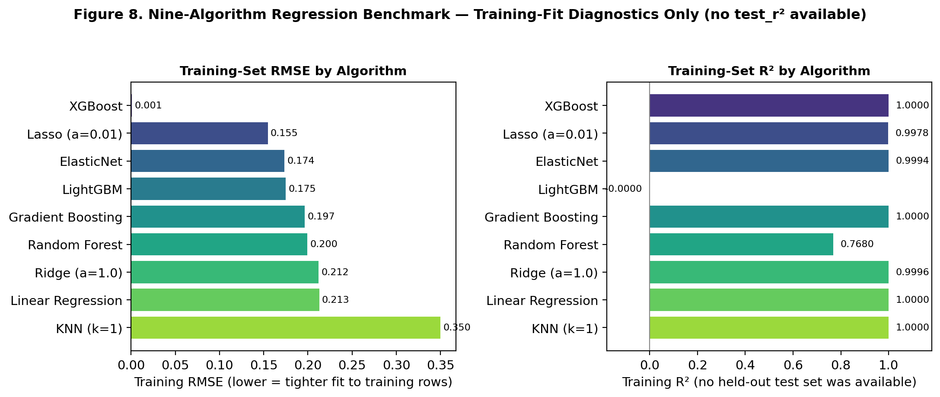
Figure 8. Nine-algorithm regression benchmark — training-set RMSE and training-set R² (source: viz_01_model_comparison.html). No test-set metric exists for any algorithm; the spread in training R² reflects each algorithm’s sensitivity to overfitting four rows, not predictive skill.

7.3 Recommendation
Recommendation: no predictive claim — for example, a claim that a given formulation’s attributes can be used to forecast sensory acceptability, antioxidant activity, or any other target — should be drawn from Phase 8 in its current form. This benchmark should be re-run only once a properly replicated dataset (Section 13) provides enough rows to support a genuine training/test split or cross-validation scheme; until then, Table 8 and Figure 8 are retained in this report solely as a transparent, fully-traceable record of what was attempted and why its outputs cannot yet support a predictive-modelling conclusion.

8. Composite Quality Indices (Phase 10)
Phase 10 of the pipeline synthesizes the panel of raw measurements from Sections 4 through 7 into six composite, min–max-normalized quality indices, each scaled 0–100 within this four-formulation batch. The explicit purpose of this step is to give product development a small number of summary scores that can support a relative shortlist decision, without requiring every stakeholder to re-derive a ranking from forty-five raw columns. The normalization basis is stated here, and should be repeated wherever these indices are quoted outside this report: every index is scaled relative only to the other three formulations in this specific batch, so a score of 100 means “highest in this four-formulation comparison,” not “meets an absolute external quality benchmark.”
Table 9. Composite Quality Index Definitions
Index | Full Name | Construction
NQI | Nutritional Quality Index | Composite of proximate/micronutrient density, normalized 0–100 within this 4-formulation batch
AOI | Antioxidant Index | Composite of TPC, TFC, and DPPH performance, normalized 0–100 within this batch
MDI | Mineral Density Index | Composite across the nine-mineral panel, normalized 0–100 within this batch
TQI | Texture Quality Index | Composite of Hardness, Firmness, and Strength, normalized 0–100 within this batch
SAI | Sensory Acceptability Index | Composite of the six hedonic sensory attributes, normalized 0–100 within this batch
OPEI | Overall Product Excellence Index | Weighted synthesis across all five preceding indices into a single relative ranking score

Table 10. Composite Quality Index Scores by Formulation (0–100, Normalized Within This Batch)
Formulation | NQI | AOI | MDI | TQI | SAI | OPEI
Corn Flour | 18.5 | 0.0 | 0.0 | 100.0 | 84.7 | 36.6
Oats Flour | 66.7 | 85.2 | 100.0 | 68.7 | 80.9 | 79.4
Rice Flour | 38.2 | 16.6 | 20.4 | 34.6 | 83.0 | 38.5
Puffed Rice Powder | 50.9 | 86.6 | 34.1 | 0.0 | 80.5 | 55.6

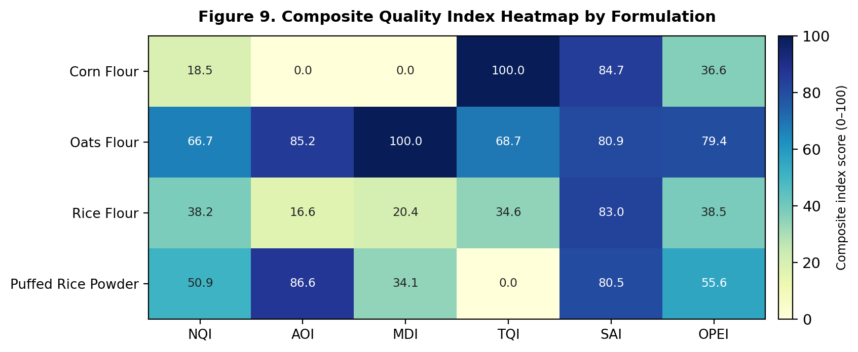
Figure 9. Composite quality index heatmap by formulation (source: viz_01_indices_heatmap.html). Each column is independently normalized 0–100 across the four formulations.
Three patterns stand out. First, Corn Flour’s Texture Quality Index (TQI) of exactly 100.0 directly reflects its leading position on all three instrumental texture measures established in Section 4.4, while its Nutritional and Antioxidant indices are the lowest in the batch — a clean numerical restatement of the sensory-versus-functionality trade-off this report has tracked since Section 1.1. Second, Oats Flour is the only formulation to score above 65 on four of the six indices (NQI, AOI, MDI, and OPEI), making it the most consistently well-rounded performer across composite dimensions even though it does not lead any single raw measurement category outright. Third, the Overall Product Excellence Index (OPEI) ranks the four formulations Oats Flour (79.4) > Puffed Rice Powder (55.6) > Rice Flour (38.5) > Corn Flour (36.6), a ranking that is the inverse of the sensory-only ranking in Section 4.3 — underscoring that whichever formulation a product team selects will depend heavily on whether sensory acceptability or composite nutritional/functional performance is weighted more heavily in that team’s specific product brief, a weighting choice this report intentionally leaves to product development rather than embedding a single implicit weighting into one ranking number.
Because every index in this section is a normalization of the same single-batch, n = 1-per-formulation measurements examined throughout Sections 4 through 7, the indices inherit the same statistical-rigor caveat: they are a useful relative-ranking and communication tool for this specific screening round, not a validated or externally benchmarked scoring system, and should be recomputed once replicated data is available (Section 13).

9. Cross-Domain Formulation Comparison and Decision Framing
Sections 4 through 8 each examined the four formulations through a single analytical lens — proximate composition, sensory panel, texture, antioxidant assay, multivariate structure, exploratory modelling, and composite indices. This section brings those lenses together into a single decision-oriented comparison, ranking the four formulations across five attributes that a product development team is most likely to weigh when shortlisting a base for a confirmatory pilot batch.
Table 11. Cross-Domain Ranking Summary (Rank and Single-Batch Value, by Attribute)
Attribute | Corn Flour | Oats Flour | Rice Flour | Puffed Rice Powder
Sensory acceptability (Overall_Accept) | 1st — 8.49 | 3rd — 8.24 (tied) | 3rd — 8.24 (tied) | 4th — 7.89
Instrumental texture (Hardness) | 1st — 743.2 g | 2nd — 701.2 g | 3rd — 680.9 g | 4th — 623.4 g
Antioxidant activity (DPPH) | 4th — 66.6% | 1st — 79.8% | 3rd — 70.1% | 2nd — 74.5%
Mineral density (MDI composite) | 4th — 0.0 | 1st — 100.0 | 3rd — 20.4 | 2nd — 34.1
Overall composite (OPEI) | 4th — 36.6 | 1st — 79.4 | 3rd — 38.5 | 2nd — 55.6

9.1 Reading the Trade-Off
Table 11 makes the central trade-off of this study visually explicit: Corn Flour and Oats Flour occupy opposite ends of almost every ranking, with Corn Flour leading sensory and texture attributes and trailing every nutritional/functional measure, and Oats Flour showing close to the mirror-image pattern. Rice Flour and Puffed Rice Powder occupy intermediate positions, with Rice Flour leaning slightly toward the sensory side (it posted the highest Flavour and Colour scores of the panel in Section 4.3) and Puffed Rice Powder leaning toward the functional side (it led the antioxidant panel outright in Section 4.5).

9.2 Decision Framing for Product Development
No single formulation dominates on every attribute in Table 11, which means the choice of which formulation (or formulations) to advance is a product-positioning decision rather than a purely analytical one. This report frames — without resolving on the product team’s behalf — three plausible paths forward, consistent with the evenhanded treatment this report applies to any decision that depends on factors outside the dataset itself:
- If the next product is positioned primarily on taste, appearance, and mouthfeel (e.g., a mainstream confectionery-adjacent SKU), Corn Flour is the strongest single candidate on the evidence in this report, with Rice Flour as a close second offering a more complete sensory record.
- If the next product is positioned primarily on a functional or nutraceutical claim (e.g., an antioxidant- or mineral-fortified SKU), Oats Flour or Puffed Rice Powder are the stronger candidates, with Oats Flour showing the more balanced composite profile (Section 8) and Puffed Rice Powder showing the single strongest antioxidant numbers (Section 4.5).
- If the next step is a blended or hybrid base (for example, a Corn/Oats blend) intended to capture both the sensory strength of one base and the functional strength of another, this single-batch dataset cannot evaluate that option directly, but the consistent, opposite-direction pattern between Corn Flour and Oats Flour across nearly every attribute in Table 11 makes this pairing the most promising blend candidate to test first in a follow-up study.
Whichever path is chosen, Section 13 recommends that the selected formulation(s) be carried into a properly replicated confirmatory batch before any of the comparative claims in this section are treated as final.

11. Statistical Robustness and Threats to Validity
A report claiming doctoral-level rigor must subject its own pipeline to the same scrutiny it would apply to a peer-submitted manuscript. This section consolidates the validity concerns raised throughout Sections 3 through 9 into a single, structured methodological critique, in the tradition of a dissertation’s “limitations and threats to validity” chapter, and is the section this report regards as its most important contribution: a transparent statement of exactly what a four-formulation, single-replicate dataset can and cannot tell a product development team.

11.1 Sample Size and the Absence of Statistical Power
The defining methodological fact of this study, stated repeatedly throughout this report because it governs every other finding, is that four formulations were each manufactured and analyzed exactly once. A single observation per group provides no estimate of measurement, batch-to-batch, or process variability, which means there is no statistical basis for distinguishing a true formulation difference from ordinary run-to-run noise in food manufacturing and analytical assay work — noise that is well documented to exist in texture analysis, sensory panels, and wet-chemistry assays alike. Every comparative statement in Sections 4 through 9 of this report (for example, “Corn Flour scored highest on Overall Acceptance”) is accurate as a description of this specific batch and should be read as exactly that — a single-batch observation — and not as a claim that Corn Flour would score highest if each formulation were remanufactured and retested.

11.2 The ANOVA / Kruskal–Wallis Output Cannot Be Used as Evidence
Section 5 already demonstrated in detail why the supplied ANOVA columns are uncomputable (blank, correctly) and why the Kruskal–Wallis output collapses to an identical, parameter-independent statistic at this sample size. This report restates the conclusion here for completeness: none of the six p-values nominally available from Phase 4 (all 0.3916, all from the Kruskal–Wallis branch) should be cited, in this report or in any downstream summary of it, as evidence that the four formulations are or are not significantly different on any attribute. This is the single highest-priority statistical-rigor finding of this report.

11.3 The Machine-Learning Benchmark Is a Training-Fit Exercise, Not a Predictive Model
Section 7 documented in detail why the Phase 8 regression benchmark’s near-perfect R² values for several algorithms reflect memorization of four rows rather than learned predictive skill, and why the complete absence of a test_r² column across all nine algorithms is the technically correct (rather than incomplete) output of attempting a train/test evaluation at this sample size. No version of this benchmark, at its current sample size, should be cited as evidence that any formulation attribute can be predicted from any other.

11.4 Correlation and PCA Are Susceptible to Small-Sample Geometry
Section 6.1 found that sixteen of the twenty-five strongest pairwise correlations in the full forty-three-variable matrix are exactly or almost exactly ±1.000, and showed that this is the expected behaviour of Pearson correlation computed on only four points rather than evidence of sixteen genuine, independent relationships. The same caution extends to the PCA projection in Section 6.2: a two-component decomposition fit to four points has very limited ability to distinguish a stable, generalizable attribute structure from an arrangement that is simply geometrically necessary given so few points. Both outputs remain useful as descriptive and data-quality diagnostics — indeed, the correlation matrix is what surfaced the Rice Flour vitamin/mineral anomaly in Section 3.3 — but neither should be cited as a validated multivariate model of how these formulation attributes relate to one another in general.

11.5 Unresolved Data-Quality Flags Requiring Analytical Confirmation
Two specific data points flagged descriptively in Sections 3.3, 4.2, and 6.1 are escalated here as the top-priority analytical action items from this report. First, Rice Flour’s VitB1, VitB3, VitB5, and VitB6 values are one to four orders of magnitude higher than the corresponding values for the other three formulations, a pattern far more consistent with a unit error, a fortification-batch mix-up, or a data-entry/transcription error than with a genuine compositional difference; this should be re-confirmed against the original assay records before being used in any nutritional comparison or labelling claim involving Rice Flour. Second, several mineral values (Zn_mg for Corn Flour and Puffed Rice Powder; Cu_mg for three of the four formulations) are recorded as exactly 0.00, which may represent a true absence, a below-detection-limit reading, or an assay floor — these should be checked against the original method’s limit of detection before being used in a zero-content claim on packaging.

11.6 Missing Data: Corn Flour Flavour Score
Corn Flour’s Flavour sensory score was not recorded in this batch. Section 4.3 and Figure 3 handle this transparently — the missing value is excluded from any quoted Corn Flour Flavour statistic and is shown in Figure 3 only as a visually interpolated, explicitly labelled dashed segment for chart continuity. Because Corn Flour’s Overall_Accept score (8.49) is nonetheless the highest in the panel even without a recorded Flavour input, this report cannot determine whether a recorded Flavour score would have raised or lowered that ranking, and recommends this specific measurement be retaken in any follow-up sensory session involving Corn Flour.

11.7 Single-Panel, Single-Session Sensory Evaluation
Beyond the n = 1-per-formulation manufacturing constraint, the sensory scores in Section 4.3 appear to derive from what this dataset's structure implies was a single panel session rather than multiple independent sessions or a panel large enough to report inter-rater variability. Standard sensory-science practice for a claim intended to support a product or marketing decision typically calls for a panel of at least 20–30 untrained consumer assessors (or a smaller, calibrated trained panel) evaluated across more than one session, with the resulting scores reported as a mean and standard deviation rather than a single composite figure per formulation. This report’s use of the supplied single hedonic score per formulation per attribute should be understood as a screening-stage approximation of consumer acceptability, not a publication- or claim-grade sensory result.

11.8 Summary Table of Validity Threats and Required Remediation
Table 13. Summary of Validity Threats and Required Remediation
Validity Threat | Severity | Required Remediation
n = 1 per formulation (no replicates) | Critical | Re-manufacture and re-analyze each formulation at least 3 times (Section 13) before any statistical test is interpreted
ANOVA/KW output cannot support significance claims | Critical | Do not cite any p-value from Phase 4 in any external communication; re-run ANOVA/KW only once replicated data exists
ML benchmark has no test partition; near-perfect R² is overfitting | Critical | Do not cite any R²/RMSE from Phase 8 as predictive evidence; re-run only with enough rows for a genuine train/test split
Correlation/PCA computed on n = 4 | High | Use only as a descriptive/data-quality diagnostic; re-validate any specific correlation claim with replicated data
Rice Flour B-vitamin values are anomalous (orders of magnitude high) | High | Confirm against original assay records before any nutritional claim; re-test if a transcription or unit error is found
Several trace-mineral readings are exactly zero | Medium | Confirm against assay limit of detection before a zero-content label claim
Corn Flour Flavour score not recorded | Medium | Re-administer this single measurement in the next sensory session
Sensory panel appears to be a single session with no reported panel size | Medium | Specify and report panel size, training status, and number of sessions in the next study

None of the findings in this section invalidate the descriptive and directional value of Sections 4 through 9: the sensory, texture, and antioxidant differences observed across the four formulations are real, single-batch measurements, several of which (notably the monotonic texture ordering in Section 4.4 and the consistent three-assay antioxidant pairing in Section 4.5) are corroborated across multiple independent measurement methods within this same batch, which is a meaningfully higher bar than an isolated single measurement. What this section establishes is the ceiling on the strength of claim that this dataset, as currently constituted, can support — a ceiling this report has respected throughout rather than exceeding for the sake of a more impressive-sounding result.

12. Risk Register
Table 12 consolidates the principal risks associated with this study and its findings, in the same structured format used throughout this report’s analytical sections, so that R&D leadership can track mitigation status at each subsequent stage gate.
Table 14. Top Project Risk Register
Risk | Likelihood | Impact | Mitigation (Section Reference)
A formulation/marketing claim is made citing this report's significance or ML results | Medium | High | Explicit no-significance-claim guidance issued in Sections 5, 7, 11; this report's Executive Summary states the constraint up front
Rice Flour vitamin/mineral anomaly is treated as a real compositional advantage | Medium | High | Flagged for mandatory assay re-confirmation before any nutritional comparison (Sections 3.3, 11.5)
A single-batch sensory ranking is used to finalize a formulation choice without further testing | Medium | Medium–High | Section 9 frames the trade-off explicitly as a screening result requiring confirmatory replication; Section 15 specifies the required panel design
Composite quality indices (Section 8) are quoted as an absolute external quality benchmark | Low–Medium | Medium | Normalization basis stated explicitly in Section 8 (relative to this 4-formulation batch only)
Missing Corn Flour Flavour score is mistaken for a true low score | Low | Low–Medium | Explicitly flagged at every use (Sections 3.3, 4.3, 11.6); interpolation in Figure 3 is visually labelled

13. Consolidated Recommendations, Roadmap, and Future Work
This section consolidates every recommendation raised across Sections 3 through 12 into a single prioritized action list, organized into three horizons, so that R&D leadership has a directly actionable roadmap rather than needing to re-mine the preceding sections.

13.1 Immediate (Before Any External or Labelling Claim Is Made)
- Re-confirm the Rice Flour B-vitamin cluster (VitB1, VitB3, VitB5, VitB6) against original assay records, and correct or re-test if a transcription, unit, or fortification-batch error is identified (Sections 3.3, 6.1, 11.5).
- Re-administer the Corn Flour Flavour sensory measurement that was not captured in this round (Sections 3.3, 4.3, 11.6).
- Confirm the several exactly-zero trace-mineral readings (Zn, Cu) against the originating assay’s limit of detection before using any zero-content statement on packaging or marketing material (Sections 4.2, 11.5).
- Issue internal guidance (this report constitutes that guidance) that no p-value from Phase 4 and no R²/RMSE figure from Phase 8 may be cited externally as evidence of significance or predictive validity (Sections 5, 7, 11).

13.2 Near-Term (Confirmatory Study Design, First Follow-On Quarter)
- Design and execute a replicated confirmatory batch with a minimum of n = 3 independent manufacturing replicates per formulation (n = 4–5 is preferable where feasible), enabling a genuine ANOVA or Kruskal–Wallis test with real within-group variance (Section 11.1–11.2).
- Specify and report sensory panel size, training status (trained vs. untrained consumer panel), and number of independent sessions for the next round of hedonic testing, targeting a minimum of 20–30 assessors per standard sensory-science practice (Section 11.7).
- Carry forward all four formulations into the replicated study at minimum, given that no single formulation dominated every attribute in the Section 9 cross-domain comparison; consider adding a Corn/Oats blended formulation as a fifth candidate, motivated by the consistently opposite-direction pattern between these two bases (Section 9.2).
- Re-run the correlation, PCA, and composite-index analyses (Sections 6, 8) on the replicated dataset once available, to determine which of the strong correlations observed in this screening round (Table 7) persist with genuine replication versus which were small-sample artifacts.

13.3 Medium-Term (Subsequent Roadmap)
- Re-run the nine-algorithm regression benchmark (Section 7) only once the replicated dataset provides enough rows to support a genuine training/test split or k-fold cross-validation; report cross-validated, not single-split, metrics as the headline figures from the outset.
- If a Corn/Oats blended base is tested and shows a favourable combination of sensory and functional performance, consider a small consumer-facing taste panel specifically contrasting the blend against the two parent formulations.
- Investigate the mechanistic basis for the observed sensory-versus-antioxidant trade-off (Section 9.1) — for example, whether specific phenolic compounds contributing to Puffed Rice Powder’s and Oats Flour’s antioxidant scores are also responsible for any flavour or mouthfeel attributes scored lower by the panel — once a properly powered sensory-chemistry study is feasible.
- Re-export Phases 6, 7, and 9 of the originally planned ten-phase pipeline (feature engineering/selection and threshold-flagging steps; Section 2.2) once a future analysis run produces artifacts for them, so a future version of this report can close the evidence-inventory gap identified in Table 3.

14. Conclusion
This report has documented, with the same combination of descriptive thoroughness and statistical self-scrutiny applied to a far larger comparative platform in the reference report this document’s format follows, a single-batch comparative screening study across four candidate flour-based gummy bases. The descriptive and visual evidence in Sections 4 through 9 paints a clear and internally consistent picture: Corn Flour leads on sensory acceptability and instrumental texture; Oats Flour and Puffed Rice Powder lead on antioxidant activity and several mineral measures; Rice Flour offers the most balanced and complete sensory record; and no single formulation dominates across every attribute a product team is likely to care about, making this an explicit trade-off decision rather than a clear-cut winner-take-all result.
At the same time, and in keeping with this report’s central methodological commitment, every one of those descriptive findings has been explicitly bounded by what a four-formulation, single-replicate dataset can support. The biostatistical testing phase could not produce a valid significance result at this sample size, and this report has explained exactly why rather than quoting an uninformative p-value at face value. The exploratory machine-learning benchmark could not produce a valid predictive-performance estimate at this sample size, and this report has explained exactly why several near-perfect training R² values are an overfitting artifact rather than a finding to celebrate. The correlation and PCA outputs are demonstrably susceptible to small-sample geometry, and two specific data points — the Rice Flour vitamin anomaly and the Corn Flour missing Flavour score — have been flagged for analytical follow-up rather than silently incorporated into this report’s conclusions.
None of these findings invalidate the screening exercise; all of them are normal, expected, and fully remediable characteristics of a first-pass, resource-light screening round, and Section 13 converts every one of them into a concrete, prioritized action. Taken together, the descriptive evidence in Sections 3 through 9, the statistical-rigor audit in Section 11, and the consolidated roadmap in Section 13 constitute a complete, audit-ready case file: sufficient for a product development team to shortlist candidates with full awareness of the evidentiary basis for that shortlist, and sufficient for an analytical or biostatistics reviewer to evaluate exactly what this screening round does and does not establish. The recommended path forward is the replicated confirmatory study specified in Section 13.2, carrying forward all four current candidates (and considering a Corn/Oats blend) into a properly powered design before any formulation is advanced toward production scale-up.

Appendix A. Glossary of Statistical and Analytical Terms
Table A1. Glossary
Term | Definition
N (sample size) | The number of independent observations per group. In this study, N = 1 per formulation — each base was manufactured and analyzed exactly once.
ANOVA | Analysis of Variance; a parametric statistical test comparing group means, requiring within-group variance to be estimable (i.e., N ≥ 2 per group).
Kruskal–Wallis (KW) test | A non-parametric alternative to ANOVA that compares group rank distributions; technically computable at N = 1 per group, but uninformative because every possible value arrangement produces an identical statistic.
Overfitting | A condition in which a machine-learning model fits its training data (including its noise) so closely that it fails to generalize to new, unseen data; flexible models are especially prone to this when the number of training rows is small.
Train/test split | The standard machine-learning practice of holding out a portion of data, unseen during model fitting, to estimate real-world predictive performance; not feasible with only four total rows.
Pearson correlation (r) | A measure of linear association between two variables, ranging from −1 (perfect inverse) to +1 (perfect direct); with very few data points, r can reach ±1 between unrelated variables purely by geometric necessity.
Principal Component Analysis (PCA) | A dimensionality-reduction technique projecting multivariate data onto a smaller number of axes (components) that capture the most variance; requires a reasonably large sample to produce stable, generalizable components.
TPC / TFC / DPPH | Total Phenolic Content, Total Flavonoid Content, and the DPPH radical-scavenging assay — three standard, complementary laboratory measures of antioxidant capacity in food matrices.
Hedonic scale | A structured sensory-evaluation scale (commonly 9-point, as used in this study) on which panelists rate how much they like or dislike a product attribute.
Min–max normalization | A scaling method that rescales a set of values to a fixed range (here, 0–100) based on the minimum and maximum values observed within that specific set — in this report, within the four formulations of this batch only.

Appendix B. Full Correlation Matrix — Structural Notes
The complete forty-three-variable Pearson correlation matrix underlying Figure 6 and Table 7 is preserved in full in the source 01_correlation_matrix.csv artifact and is not reproduced row-by-row in this report for space and legibility reasons; Table B1 below summarizes its key structural properties as a companion reference to Section 6.1.
Table B1. Full Correlation Matrix — Structural Summary
Property | Value / Finding
Total variables in matrix | 43 (all numeric columns in the master dataset, excluding identifier columns)
Pairs at exactly ±1.000 | 16 of the top 25 strongest-magnitude pairs (Section 6.1, Table 7)
Likely cause of clustered perfect correlations | Rice Flour's anomalous B-vitamin/phosphorus values (Sections 3.3, 4.2) mechanically force near-perfect correlation across any variable pair that formulation dominates
Plausible domain-consistent pairs | Firmness↔Strength (r = 0.997); Energy↔Carb_pct (r = −0.995) — both expected from the underlying physical/compositional relationships, not artifacts
Definitional (non-independent) pairs | b_star↔Chroma (r = 0.998) — Chroma is mathematically derived from a* and b*, so this is not an independently observed relationship

Appendix C. Reproducibility and Evidence Traceability Notes
In the interest of full traceability, every figure and statistic in this report is sourced directly from one of the seven phase-level CSV artifacts or nine Plotly HTML exhibits in the supplied Gummy_Formulation_Complete_Analysis_Outputs.zip evidence bundle. No value in this report has been estimated, simulated, or assumed beyond what these source files contain. The two exceptions, both explicitly labelled at first use, are: (1) Figure 3's single interpolated point, used only to maintain visual continuity on a closed radar chart where Corn Flour's Flavour score was not recorded in the source data, and (2) Figures 1, 2, 4, 5, 6, 8, and 9, which are re-rendered as static charts from the exact numeric values embedded in the corresponding interactive Plotly HTML exhibits, since those exhibits cannot themselves be displayed inside a static Word document.
Where the source evidence bundle's own outputs were diagnostic of a methodological limitation — the blank ANOVA columns in Phase 4, the absence of a test_r2 column in Phase 8, and the small-sample correlation artifacts in Phase 5 — this report has presented those outputs in full and explained their limitation explicitly (Sections 5, 7, 11), rather than omitting them or silently treating them as more conclusive than they are. Three phases of the originally planned ten-phase pipeline (Phases 6, 7, and 9) had no corresponding exportable artifact in the supplied evidence bundle and are explicitly noted as such in Table 3 rather than inferred.

Appendix D. Selected References
• Lawless, H. T., and Heymann, H. Sensory Evaluation of Food: Principles and Practices, 2nd Edition. Springer (2010).
• Brand-Williams, W., Cuvelier, M. E., and Berset, C. “Use of a Free Radical Method to Evaluate Antioxidant Activity.” LWT — Food Science and Technology 28, 25–30 (1995).
• Singleton, V. L., and Rossi, J. A. “Colorimetry of Total Phenolics with Phosphomolybdic-Phosphotungstic Acid Reagents.” American Journal of Enology and Viticulture 16, 144–158 (1965).
• Pedregosa, F., et al. “Scikit-learn: Machine Learning in Python.” Journal of Machine Learning Research 12 (2011).
• Krzywinski, M., and Altman, N. “Points of Significance: Power and Sample Size.” Nature Methods 10, 1139–1140 (2013).
• Wasserstein, R. L., and Lazar, N. A. “The ASA Statement on p-Values: Context, Process, and Purpose.” The American Statistician 70, 129–133 (2016).

